- May 7th-10th, 2019  22nd Annual CCOSO Training Conference  The California Coalition on Sexual Offending  Presents our Annual Training Conference in Gorgeous San Ramon California for four days of specialized training in the Treatment and Management of sexual abusers. |  | A World Without Sexual Abuse  Key Note Address by  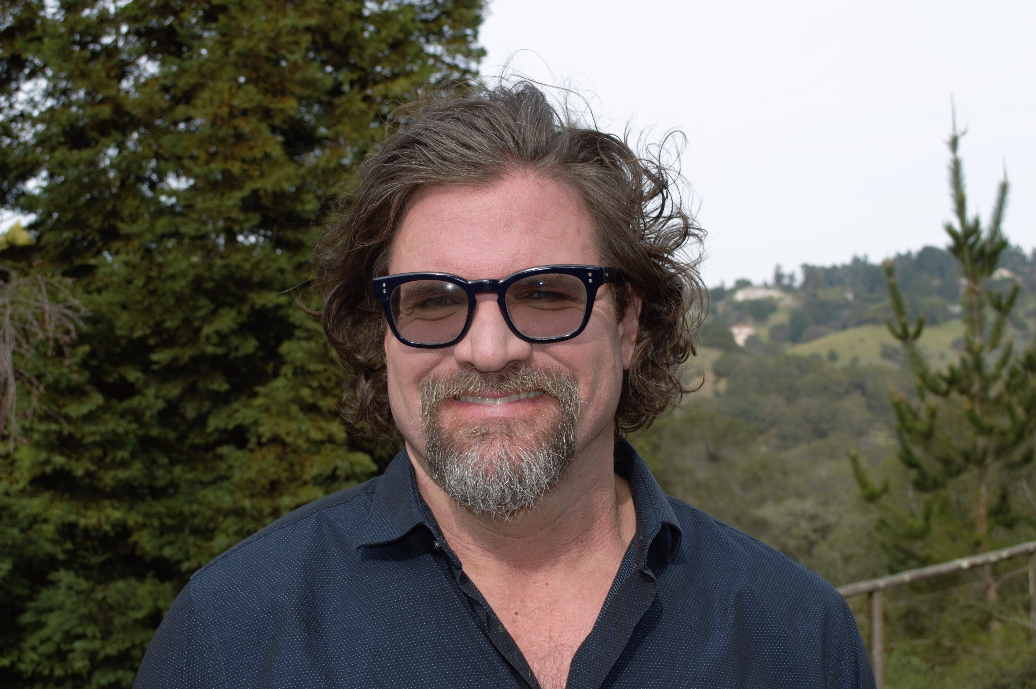  Charles A. Flinton, Ph.D.  Founder & Clinical Director of the  San Francisco Forensic Institute  “New Directions in Prevention: Meaning and Purpose for  Stakeholders and Front-line Clinicians”  Please consider joining us for a week of interesting & educational trainings, providing Continuing Education Units, or Standards in Corrections Training Credits as well as meeting some of the training requirements for certification as a treatment practitioner through the California Sex Offender Management Board.  In the Bay Area town of San Ramon, this year’s conference will be held at  San Ramon Marriott  2600 Bishop Drive  San Ramon CA. 94583  